Small Office/Home Office and IoT Network Design and Implementation

Sibgha Mursaleen
BE- Computer Systems Engineering
Sukkur IBA University
sibghamursaleen.becsef22@suk-iba.edu.pk

Abstract – In today’s interconnected world, efficient and secure network are vital for small offices and home offices (SOHO), enabling smooth operations and enhancing productivity. This project a SOHO Network Design (SND) tailored for seamless communication and integration of modern technologies like IoT, Using Cisco packet tracer, the network is structured with VLANs for traffic segmentation, subnetting for optimized IP allocation and wireless networks to support mobility. Security protocols, including WPA2 encryption and access control lists (ACLs), ensure data integrity and confidentially. The network is designed to foster secure, scalable and efficient communication among end users, offering a reliable foundation for future expansion.

Index Terms - VLANs, Cisco Packet Tracer, IoT Integration, Subnetting, Network Security

1. INTRODUCTION
A well-designed network is crucial for the efficiency and security of small office/home office (SOHO) setups. This project focuses on creating a scalable, secure, and efficient SOHO network using Cisco Packet Tracer. Key aspects of the design include IoT integration, VLAN segmentation, and subnetting.

The network is designed to cater to multiple departments, integrate IoT devices, and ensure secure and efficient connectivity through VLANs and subnetting.

This report provides a comprehensive overview of methodology, the design, implementation steps, benefits of the network, and references.

2. METHODOLGY
The project followed a structured approach to ensure systematic design and implementation of the SOHO network. The methodology involved the following steps:
- Requirements Analysis
- Gathered detailed information on network’s needs, including the number of users, departments, and types of devices
- Established security requirements to protect data and devices from unauthorized access.
- Network Design
- Created a logical topology with a central router and a managed switch to interconnect departments (Admin/IT, Finance/HR and Customer Service).
- Designed VLANs to segregate traffic and enhance security for each department.
- Implemented subnetting concepts for proper IP address allocation and management.
- Simulation and Configuration
- Used Cisco Packet Tracer to simulate the designed network and test its functionality.
- Configured different devices, including routers, switches and PC, and DHCP for proper automatic IP address assignment
- Testing and Troubleshooting
- Ensured IoT devices communicated properly and efficiently.
- Tested the security measures

3. IMPLEMENTATION
The implementation of the SOHO network involved configuring the following components:

- Router Configuration: Configured inter- VLAN routing to enable communication between VLANs. And used DHCP to allocate IP addresses dynamically for each subnet.
- Switch Configuration: for the switch we created and assigned VLANs to specific ports
- Wireless Access Points: Configured SSIDs for each department and secured wireless networks using WPA2 encryption.
- IoT Devices: Connected smart devices (e.g., doors, fans, cameras) to the network.

3.1. Network Topology

The network topology comprises a central router and a managed switch connected to various devices, including PCs, IoT devices, and wireless access points. The switch is configured with multiple VLANs to segregated traffic from different departments, Inter-VLAN communication is enabled through the router.

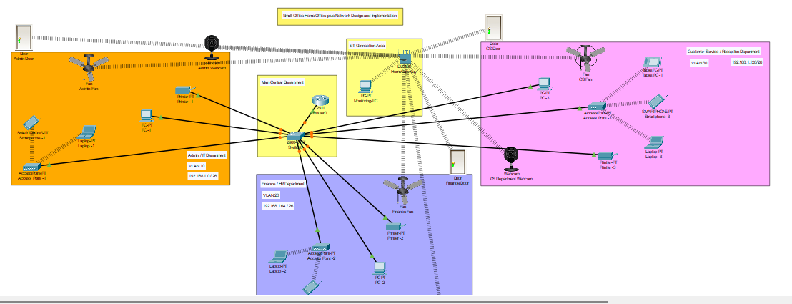

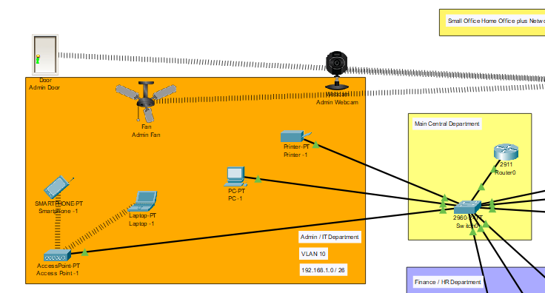

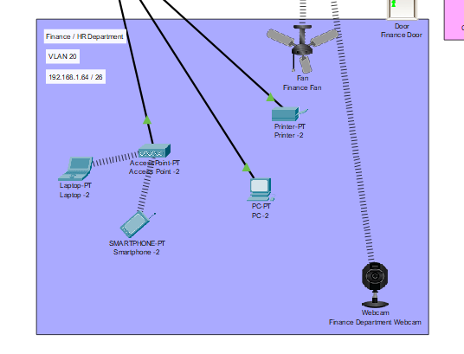

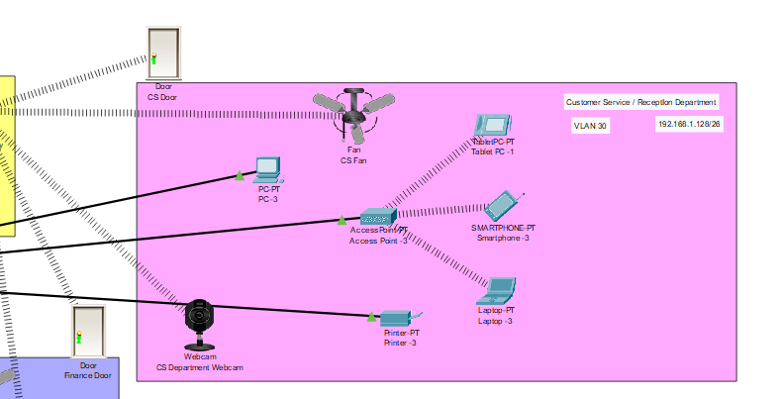

`

4. REQUIREMENTS
The SOHO network was designed to meet the following requirements:
- Use of one router (central router) and one switch.
- Three segregated departments: Admin/IT, Finance/HR, and Customer Service.
- VLAN for each departments for segregate traffic, security and organization.
- Wireless networks for users in each department.
- Using DHCP for automatically IP addresses allocation.
  - Security Measures
To ensure the SOHO network’s security, several measures were implemented to protect the data from any kind unauthorized access.

VLAN was implemented to isolate the network traffic of each department, ensuring that the devices within a VLAN could communicate internally while restricting access from other VLANs. This increases the overall performance of network and security.
For the wireless networks, WPA2 encryption was implemented to secure communication providing protection against any kind of unauthorized access. This ensures that only authenticated users can access the wireless network.

5. CONCULSION
The SOHO network design demonstrates a robust and scalable approach to connecting devices in small office environments. By incorporating VLANs, subnetting, and IoT integration, the network achieves enhanced security, efficiency and flexibility. The implementation provides a foundation for future scalability and ensures reliable communication across departments.

6. REFERENCES
- Cisco Packet Tracer Documentation: Official Cisco resources on network simulation and configuration.
- Networking Fundamentals: Online tutorials and guides on VLANs, subnetting, and IoT integration.
- Project Requirements Document: Specifications provided for the SOHO network design.

